3.64: Combining equations 3.25, 3.22 and 3.23 gives
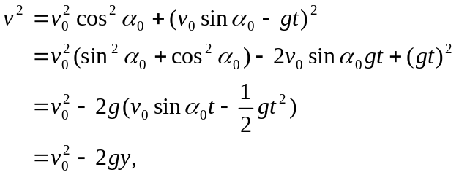

where Eq. (3.21) has been used to eliminate t in favor of y. This result, which will be seen in the chapter dealing with conservation of energy (Chapter 7), is valid for any y, positive, negative or zero, as long as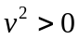. For the case of a rock thrown from the roof of a building of height h, the speed at the ground is found by substituting 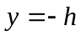 into the above expression, yielding 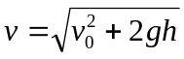, which is independent of 

